European Youth Ultimate Championships 2017

Championship
View full bracket results
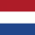
NED U20 Women's
1st
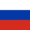
RUS U20 Women's
2nd
CZE U20 Women's
3rd
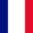
FRA U20 Women's
4th
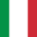
ITA U20 Women's
5th
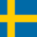
SWE U20 Women's
6th
SUI U20 Women's
7th
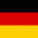
GER U20 Women's
8th
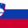
SLO U20 Women's
9th
AUT U20 Women's
10th
FIN U20 Women's
11th
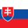
SVK U20 Women's
12th
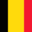
BEL U20 Women's
13th (tie)
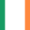
IRL U20 Women's
13th (tie)
ISR U20 Women's
13th (tie)

